**Ecrire le mot correspondant à chaque illustration. Utilise les articles : un, une, des, du…**

C:\Users\M.JO\AppData\Local\Microsoft\Windows\Temporary Internet Files\Content.IE5\HZ2A95NA\MC900353985[1].wmf  C:\Users\M.JO\AppData\Local\Microsoft\Windows\Temporary Internet Files\Content.IE5\1L7V3RZV\MC900331576[1].wmf C:\Users\M.JO\AppData\Local\Microsoft\Windows\Temporary Internet Files\Content.IE5\CJX0VE12\MC900197385[1].wmf  C:\Users\M.JO\AppData\Local\Microsoft\Windows\Temporary Internet Files\Content.IE5\1L7V3RZV\MC900312366[1].wmf C:\Users\M.JO\AppData\Local\Microsoft\Windows\Temporary Internet Files\Content.IE5\CJX0VE12\MC900232855[1].wmf

___________________________________________________________________________________________________________________________________________

 C:\Users\M.JO\AppData\Local\Microsoft\Windows\Temporary Internet Files\Content.IE5\CJX0VE12\MC900241711[1].wmf C:\Users\M.JO\AppData\Local\Microsoft\Windows\Temporary Internet Files\Content.IE5\CJX0VE12\MC900358471[1].wmf C:\Program Files\Microsoft Office\MEDIA\CAGCAT10\j0251871.wmf C:\Users\M.JO\AppData\Local\Microsoft\Windows\Temporary Internet Files\Content.IE5\CJX0VE12\MC900057616[1].wmf

___________________________________________________________________________________________________________________________________________

 C:\Users\M.JO\AppData\Local\Microsoft\Windows\Temporary Internet Files\Content.IE5\CJX0VE12\MC900361810[1].wmf C:\Users\M.JO\AppData\Local\Microsoft\Windows\Temporary Internet Files\Content.IE5\GVZ2ILEA\MC900250168[1].wmf C:\Users\M.JO\AppData\Local\Microsoft\Windows\Temporary Internet Files\Content.IE5\1L7V3RZV\MC900286322[1].wmf C:\Users\M.JO\AppData\Local\Microsoft\Windows\Temporary Internet Files\Content.IE5\1L7V3RZV\MC900290949[1].wmf

____________________________________________________________________________________________________________________________________________

  C:\Users\M.JO\AppData\Local\Microsoft\Windows\Temporary Internet Files\Content.IE5\GVZ2ILEA\MC900111364[1].wmf 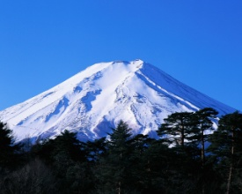 C:\Users\M.JO\AppData\Local\Microsoft\Windows\Temporary Internet Files\Content.IE5\22IJFAX1\MC900351761[1].wmf

___________________ ______ __________________________________________________________________________________________________________________

C:\Users\M.JO\AppData\Local\Microsoft\Windows\Temporary Internet Files\Content.IE5\GVZ2ILEA\MC900335751[1].wmf  C:\Users\M.JO\AppData\Local\Microsoft\Windows\Temporary Internet Files\Content.IE5\HZ2A95NA\MC900318566[1].wmf 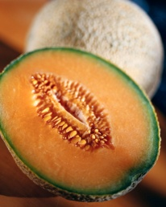 C:\Users\M.JO\AppData\Local\Microsoft\Windows\Temporary Internet Files\Content.IE5\SJNZ2NQC\MC900195390[1].wmf

________________________________ __________________________________________________________________________________________________________

C:\Users\M.JO\AppData\Local\Microsoft\Windows\Temporary Internet Files\Content.IE5\1L7V3RZV\MC900056756[1].wmf C:\Users\M.JO\AppData\Local\Microsoft\Windows\Temporary Internet Files\Content.IE5\PM3ZJ61V\MC900198655[1].wmf C:\Users\M.JO\AppData\Local\Microsoft\Windows\Temporary Internet Files\Content.IE5\CJX0VE12\MC900279144[1].wmf C:\Users\M.JO\AppData\Local\Microsoft\Windows\Temporary Internet Files\Content.IE5\SJNZ2NQC\MC900215168[1].wmf C:\Program Files\Microsoft Office\MEDIA\CAGCAT10\j0185604.wmf

**Complèter les mots sous chaque illustration avec les sons manquants : ou oi an on in**

**C:\Users\M.JO\AppData\Local\Microsoft\Windows\Temporary Internet Files\Content.IE5\CJX0VE12\MC900361810[1].wmf  C:\Users\M.JO\AppData\Local\Microsoft\Windows\Temporary Internet Files\Content.IE5\CJX0VE12\MC900197385[1].wmf C:\Users\M.JO\AppData\Local\Microsoft\Windows\Temporary Internet Files\Content.IE5\GVZ2ILEA\MC900250168[1].wmf **

un sap………… un b……..b…….. une m……..che un lap………. un mel………….

**C:\Users\M.JO\AppData\Local\Microsoft\Windows\Temporary Internet Files\Content.IE5\SJNZ2NQC\MC900215168[1].wmf C:\Program Files\Microsoft Office\MEDIA\CAGCAT10\j0185604.wmf C:\Users\M.JO\AppData\Local\Microsoft\Windows\Temporary Internet Files\Content.IE5\AJT6YT10\MC900319096[1].wmf C:\Users\M.JO\AppData\Local\Microsoft\Windows\Temporary Internet Files\Content.IE5\0Y31U8QX\MC900252199[1].wmf C:\Users\M.JO\AppData\Local\Microsoft\Windows\Temporary Internet Files\Content.IE5\2OSHJJC4\MC900350061[1].wmf**

une arm……..re une mais…….. un mout………. des s……….dales la d………che

**C:\Users\M.JO\AppData\Local\Microsoft\Windows\Temporary Internet Files\Content.IE5\0Y31U8QX\MC900356105[1].wmf 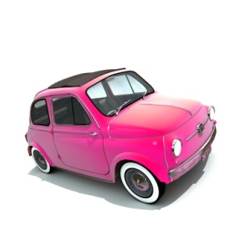 C:\Users\M.JO\AppData\Local\Microsoft\Windows\Temporary Internet Files\Content.IE5\YVVRZORR\MC900233594[1].wmf**

un éléph……….t une v………ture un p……..ss…….. r……..ge